

Sri Lanka Institute of Information Technology

Destination Management System
Design Document

Project ID: ITP/08/B-G2

Submitted by:

1. DIT/08/C1-0235 – V.Thivaharan
2. DCN/08/C3-0585 – S.Sinthana
3. DIT/08/C1-0143 – K.Kasthuri
4. DIT/08/C1-0182 – S.Mayoorika
5. DIT/08/C1-0195 – R.Darshitha
6. DIT/08/C1-0215 – P.Premje
7. DIT/08/M3-1604 – Y.Tharangini
8. DIT/08/C1-0226 – G.B.Weerasinghe
9. DIT/07/C1/0108 – S.Rajprasanth

Table of Contents

List of Acronyms and Abbreviations………………………………………………….-vi-

1. Introduction……………………………………………………………………-1-
1.1 Problem Statement…………………………………………………………..-1-
1.2 Product Scope………………………………………………………………..-3-
1.3 Project Report Structure……………………………………………………..-4-

2. Methodology……………………………………………………………………-5-
2.1 Requirements and Analysis ………………………………………………….-5-
2.1.1 Use case diagrams for WTL requirements………………………..-7-
2.1.2 Activity diagrams for WTL requirements………………………..-11-
2.2 Design……………………………………………………………………….-13-
2.2.1 Class diagram…………………………………………………….-14-
2.2.2 Sequence diagram………………………………………………..-15-
2.2.3 EER diagram……………………………………………………..-17-
2.3 Implementation………………………………………………………………-18-
2.4 Testing……………………………………………………………………….-21-

3. Evaluation……………………………………………………………………....-22-
3.1 Assessment of the Project results……………………………………………-22-
3.2 Lessons Learned…………………………………………………………….-.24-
3.3 Future Work…………………………………………………………………-24-

4. Conclusion……………………………………………………………………...-25-

5. References……………………………………………………………………...-27-

Appendix A: Design Diagrams………………………………………………………...-28-
Appendix B: Test Results…………………………………………………………….. -32-
Appendix C: Selected Code Listings…………………………………………………..-34-

List of Acronyms and Abbreviations
Activity Diagrams | Activity diagrams describe the workflow behavior of a system. Activity diagrams are similar to state diagrams because activities are the state of doing something. The diagrams describe the state of activities by showing the sequence of activities performed. Activity diagrams can show activities that are conditional or parallel.
Class Diagrams | Class diagrams are widely used to describe the types of objects in a system and their relationships.
Collaboration diagrams: | Collaboration diagrams are also relatively easy to draw. They show the relationship between objects and the order of messages passed between them.
Interaction Diagrams | Interaction diagrams model the behavior of use cases by describing the way groups of objects interact to complete the task.
Sequence Diagrams | Sequence diagrams demonstrate the behavior of objects in a use case by describing the objects and the messages they pass.
State Diagrams | State diagrams are used to describe the behavior of a system. State diagrams describe all of the possible states of an object as events occur. Each diagram usually represents objects of a single class and tracks the different states of its objects through the system.
UML | The Unified Modeling Language (UML) is a standard language for specifying, visualizing, constructing, and documenting the artifacts of software systems, as well as for business modeling and other non-software systems.
Use Case Diagrams | A use case is a set of scenarios that describing an interaction between a user and a system. A use case diagram displays the relationship among actors and use cases.

Introduction
Walkers Tours is the one of the leading company in the destination management industry in Sri Lanka. The principal activity of walkers’ tours is focusing on In-Bound Tourism and providing destination management services. Together with its brands which are well equipped to serve destination management requirements of all travelers. Destination Management System (DMS) for Walkers Tours Limited (WTL) is intended to manage client (Tourist) information such as registration details, tour details (Places, Hotels, Food and Accommodation) and payment details in an effective and efficient way within the company.

There are number of operations that are to be supported through the proposed system. Some of them are calculate the charges, update the new changes, keep track of the traveler’s details. Currently most of these are being done as paper based system and if it is going to be as it is, it will not suitable to the new technology. Hence the users see the needs for change.

The other problem which was brought to our attention was, a new traveler can select only the wanted tour-package such as Cultural triangle, Southern coastal, Hill country, classical visit, etc from our client. In some situation traveler, want to visit only particular places not according to the package. In this situation there is no such service provide by our client right now.

Our solution for this problems are automate their day-to-day functions by a standalone system, and a website with more features such as can easily keep track of the details of customers and packages through our proposed system.

To make their existing website more user friendly, we decided to introduce, select the visiting places by clicking system that is travelers can select the particular places which they want to visit by clicking not according to the package wised always.

Our other introducing feature is display the amount of a tour with tourist’s all needs after they registered, this is more helpful to tourist to take the decision of their tourist expenses. Also we are going to introduce the mileage calculation feature. That is we are going to calculate the travelling charges according the miles they travel not just package.

The reports that could be generated by the system are time schedules such as traveler’s details, reminders about upcoming celebration details, special offers details and other tourist reminders. Our system will send this generated mail to the tourist as reminders automatically. Hence satisfying all the requirements specified the project is going towards the goal of developing a reliable and easy to use tool for the DMS. All the interfaces are designed considering the user friendly factor in mind.

The vision of our project is to provide our client WTL with an accurate and efficient system to solve the existing problem domain.

Methodology

Requirements and Analysis
We planed the basic templates of our system ^{[1]} and decided to go through the Software life cycle phases.

- First we analysis of the problem.
- Collect the data which would be the system.
- Disused about the processing required to be carried out on these data.
- Got to know about the output data required to be produced by the system.
- As well as we study of various constraints on the behavior of the system.

Finally we analyzed to arrive at an abstract definition of the problem and different solution strategies. Examined of alternative solution strategies and their benefits ^{[4]}, indicating resources required, development cost and time. We determined which solution is the best. So for running the project and the organization successfully this step is a very important step in a development process.

We used Requirements Analysis phase to collect and analyze all related data and information with a view to understanding the WTL requirements clearly. We start this through interviews ^{[2]} and discussions with WTL staffs. We obtained a clear, in-depth understanding of the problem that is to be solved; already company has given some requirements such as
- Create the website more users friendly.
- Traveler can select their visiting places as their own, not according to the packages.
- Ability to view travel cost by traveler when they select their needs.
- Ability to view the tour plan by tourist after register with us.
- Tourist can pay the amount through our website online facility.
- Ability to change rates like mileage charges, vehicle charges etc.

One of the main modules in this system is ‘Online Reservation’. At this point client can get register through online to visit Sri Lanka. To develop the system gathering the requirements via the questionnaire was a major advantage that we had. The main requirements that were gathered are mentioned below.

Now WTL serving some readymade packages to their clients, compare this to the current situation in the same industry, they are allowing their clients to select their needs according to their wish and at the same time they are calculating the total cost according to tourist selection.

Following details on the clients should be tracked at the time of reservation through online. Tourist Name, Passport No, Country, Telephone No, E-mail address, No of person who is going to visit Sri Lanka and other tourist selection. It is assumed that seating capacity and weight are standard information so that kind of information is not tracked. Normally the company categorizing hotel room types as Single bed room, Double bed room and Triple bed room. To the meal types now they are categorizing as Bread & Breakfast, Half Board and Full Board. Same as in the Vehicles they are categorizing as Car, Luxury Car, Mini Coach and Coach.

Currently for each vehicle each driver is allocated and in addition to this if tourist need any guide, guide also allocated to the clients. But WTL having some language speaking tour guides with them but there is a way to give their services to client through online right new.

After tourist back from Sri Lanka new their is no way to keep track of their details or no contacts with them and right now it’s hard to get the annual feedbacks (Report or Graphs) to the Marketing officer.

Below we are describing the requirements what we got at analysis phase with WTL staff using analysis models as use case diagrams, use case scenarios & activity diagram.

2.1.1 Use case diagram

Use case for internal users

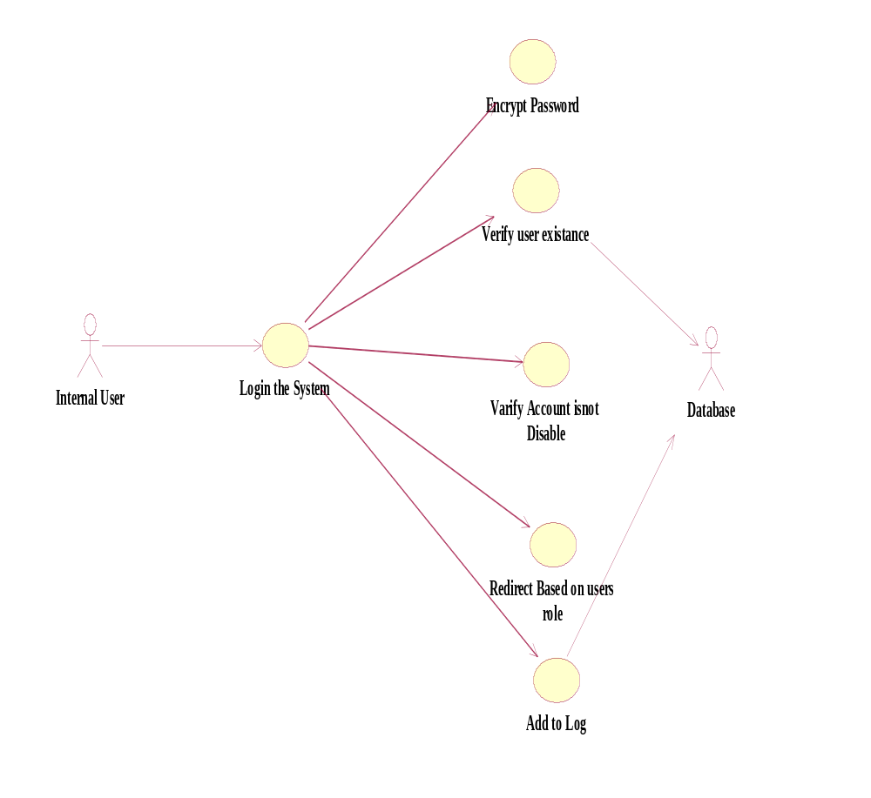

Use case for Tourist

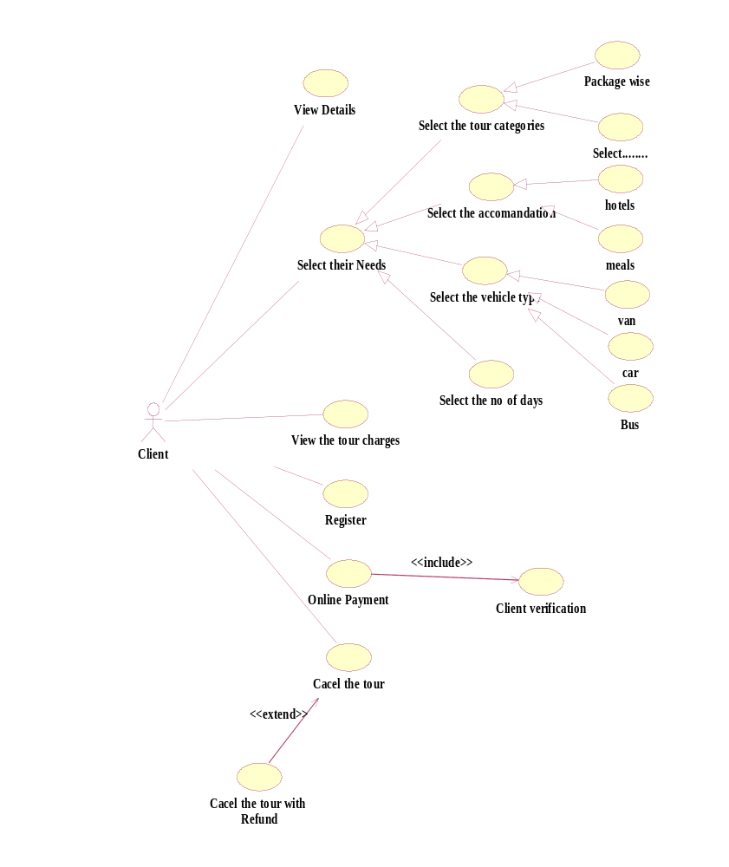

2.1.1.3 Use case for Marketing Officer

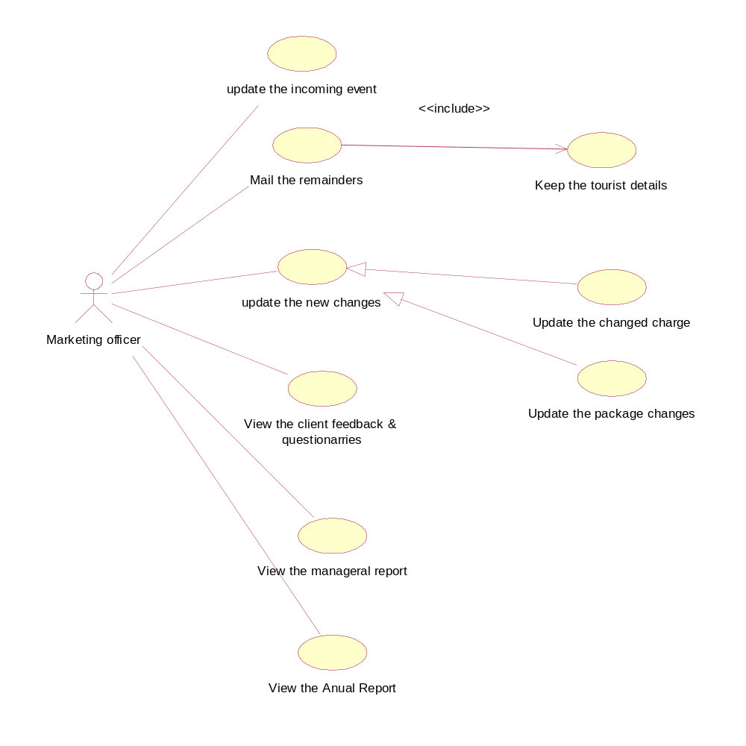

Use case for Administrator

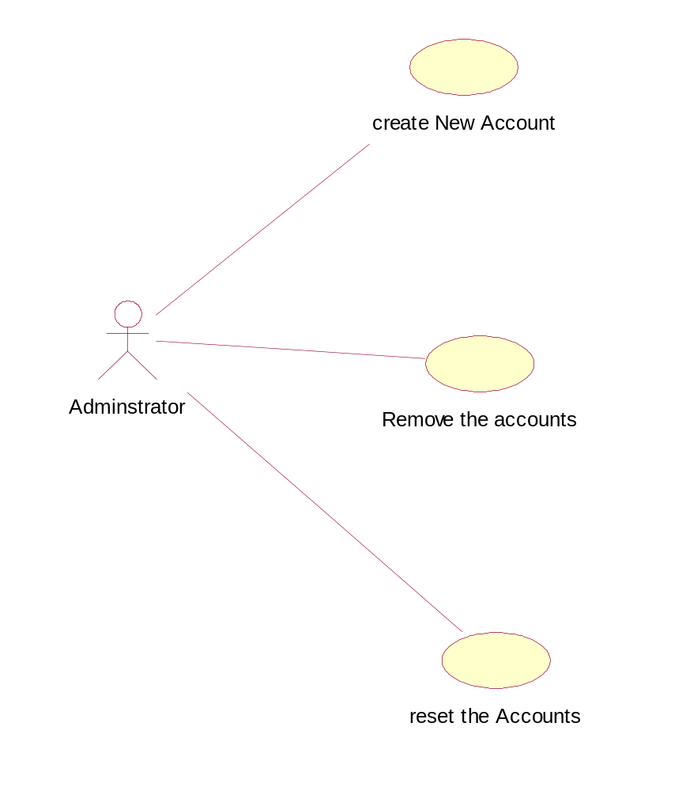

2.1.2 Product Functions
System should support the following use cases:
Class of use cases | Use Cases | Description of use cases
Use cases related to  System authorization | Login | Use to login to the system
Use cases related to  System authorization | Change Profile | Change passwords and usernames
Use cases related to  System authorization | Log Out | Logout from the system
Use cases related to  System authorization | Create new user Accounts | For new internal users
Use cases related to  Client registration | Registration | Register new clients
Use cases related to  Client registration | Edit client Details | Change existing data
Use cases related to  Client registration | Delete client Details | Remove registered data
Use cases related to  payments | Make Payment | Enter payment details
Use cases related to  payments | Refund | Enter cancellation details
Use cases related to  Calculation | Calculate Mileage charges according to places selection. | Enter Place details
Use cases related to  Calculation | Calculate Package charges | Enter package details
Use cases related to  Calculation | Calculate Hotel charges | Enter Hotel details
 | Calculate foods charges | Enter meal type
 | Calculate Guide charges | Enter Guide details
 | Calculate vehicles charges | Enter vehicles details
Use cases related to  Update events | Calculate Service Charges | Enter service details
Use cases related to  Update events | Calculate Day charges | Enter no of days going to stay
Use cases related to  Update events | Mail upcoming events | Enter upcoming details
Use cases related to mail reminders | Mail reminders to registered tourist | Enter tourist details
Use cases related to  Cancelling registration | Cancel registered Details | Enter cancellation details
Use cases related to  Produce reports | Produce reports details | Enter management functions

Use case scenarios
Use Case 1: Login
Primary Actors: Administrator, Accountant, Marketing officer.
Pre-Condit ion: System should be up
Main Scenario:
- Use case starts when an actor needs to login to the system
- User prompted for User Name and Pass Word
- User enter his own User Name and Password
- System does the authentication
- Display the main screen specific for that user.
Extensions:
3. (a) Username or password is not entered
- (a)1. Prompt the user Username or password is not entered.
- (a)1 . Allow him to enter user name or password.
4. (a) User Name or Pass Word is not valid
- (a) 1. Prompt the user invalid User name or password
- (a) 1. Allow user to re-enter invalid username or password. Give him 3 times.

Post Condition: User’s main screen should display.

Use Case 2: Tour selection

This use case will provide the capability of select tour.

Primary Actor: Client (Tourist)

Pre-Condition: System should be up

Main Scenario:
- System displays a screen which contains the Tour category (with initially blank text boxes or selectable option buttons).
- Select the tour category.
- Select the Hotels.
- Select the food type.
- Select the vehicle type.
- Select the additional services.
- System prompts the total amounts and selected details.
- System is updated with new details.
- End Use Case

Extensions:
- (a) Total amount exceed reselect the services.

Post- Condition: Database should be updated

Use Case 3: Registration
This use case will provide the capability of registering for tour.
Primary Actor: Client (Tourist)
Pre-Condition: System should be up
Main Scenario:
- System display a screen which contains following fields (with initially blank text boxes or selectable option buttons) as required by the user
Personal Details: Client Name
Nationality
Date of Birth
Sex
Passport number
Country
Contact Details: Permanent Address
Telephone Number
Email Address
Tour Details: Starting date of tour
Payment type
Payment date
2. System is updated with new details.
3. End Use Case
Extensions:
1.(a) Client passport number or Payment date or Payment type or amount is not entered
1.(a) 1. Prompt the user enter passport number or Payment date or Payment -type.
1. (b) 1.Ivalid passport number
1.(b) 2. Prompt the user he has entered an invalid passport number.
Post- Condition: Database should be updated

Use Case3: Make Payment

This use case will help the client to handle the payments for a tour.
Primary Actor: Client (Tourist)
Pre-Condition: Client should be a registered student

Main Scenario:
- Client initiates the make payment command.
- System prompted a form for following details
Registered Number
Payment Date
Payment Type (Full Payment/Installment)
Amount
Name
PIN number
- Enter and save details
- System is updated with new details.
- End use case

Extensions:
3. (a) Registered number or Payment date or any field is not Entered
3. (a) 1. Prompt the user enter particular field.

3. (b) Invalid PIN number
3. (b) 1. Prompt the user he has entered an invalid PIN number.

3. (c) Account balance is not enough
3. (c) 1. Prompt the user that account balance is not enough.

Post- Condition: Database should be updated

Use Case 4: Sending Reminders.
This use case needs to send e-mails for the clients reminding about their tour.
Primary Actor: System
Pre-Condition: System is up and running
Main Scenario:
- System is automatically initiates this use case.
- Get the list of clients who need to remind for the tour (before one weeks to tour)
- Send e-mails to them informing that the tour details.
- End Use Case
Extensions:
2. (a) Cancel the registration who register for tour.
2. (a) 1. Prompt a message telling No reminds needed for this moment.
Post- Condition: All the relevant clients receive an e-mail

Use Case5: update upcoming events
This use case allows marketing officer to update upcoming events.
Primary Actor: Marketing officer
Pre Condition: User logged in
Main Scenario:
    - User initiates the Give command.
    - User can update the upcoming events.
    - System is updated with new events.

Use Case 6: Create new account

This use case allow administrator to create new account for new internal users.

Primary Actor: Administrator.

Pre Condition: user logged in

Main Scenario:
1. User initiates the create account command
2. User is prompted for username, WTL I.C no, account type, set username, set password.
3. User gives the username, WTL I.C no, account type, set username, set password.
4. System does authentication
5. New account is registered with the system

Extensions:
4 (a). Authentication Fails
4 (a)1. Prompt the user that he typed the wrong WTL I.C
4 (a)2. Allow him to re-enter the WTL I.C

Use Case 7: Change Profile
This use case allow user to change the password that is using currently.
Primary Actor: Administrator, Accountant, Marketing officer.
Pre Condition: user logged in
Main Scenario:
1. User initiates the change profile command
2. User is prompted for old password, new password and confirm new password
3. User gives the old password and new passwords and confirms the new password
4. System does authentication
5. New password is registered with the system
Extensions:
4 (a). Authentication Fails
4 (a)1. Prompt the user that he typed the wrong password
4 (a)2. Allow him to re-enter the password. Give him 3 chances.
4 (b). New password and confirm password do not match.
4 (b)1. Allow him to re-enter the attributes. Give him 3chances.

Use Case 6: Log Out
This use case allows users to log out from the system.
Primary Actor: Administrator, Accountant, Marketing officer
Pre Condition: user logged in
Main Scenario:
- User initiates the Log Out command
- User is prompted for confirmation.
- User Log Out.
Extensions:
2. (a) cancel the confirmation
2. (a) 1. User will not Log Out

Activity Diagrams for WTL Requirements

Activity Diagram for Client Registration

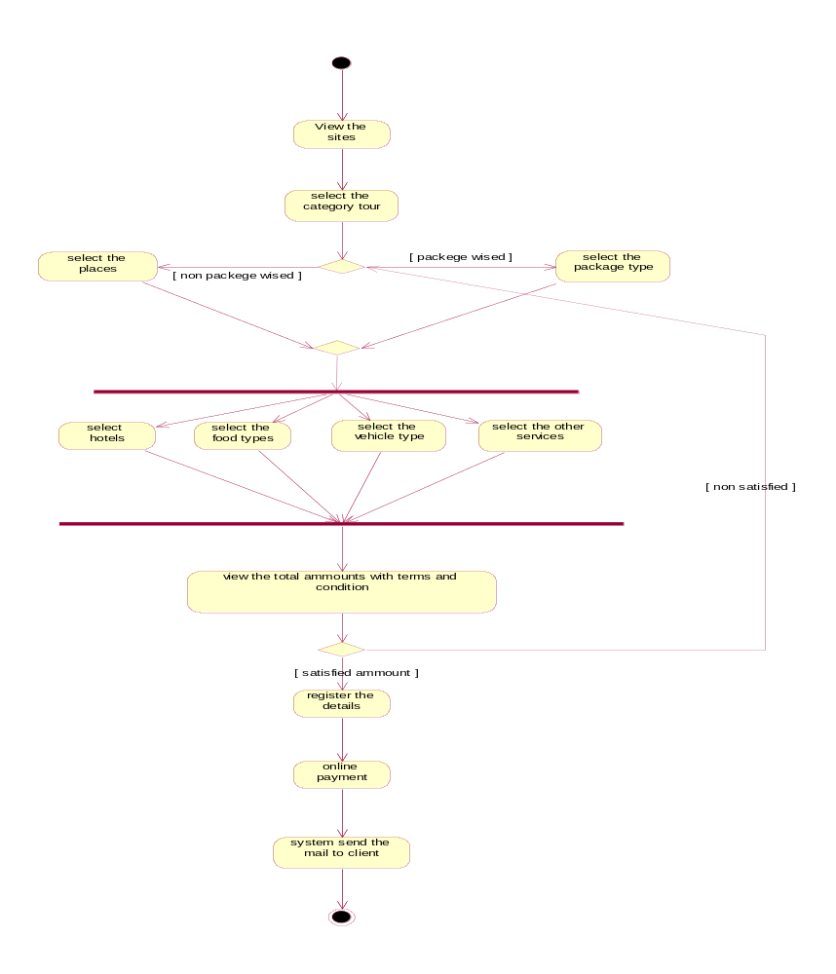

Activity Diagram for WTLs’ Internal user’s Activities
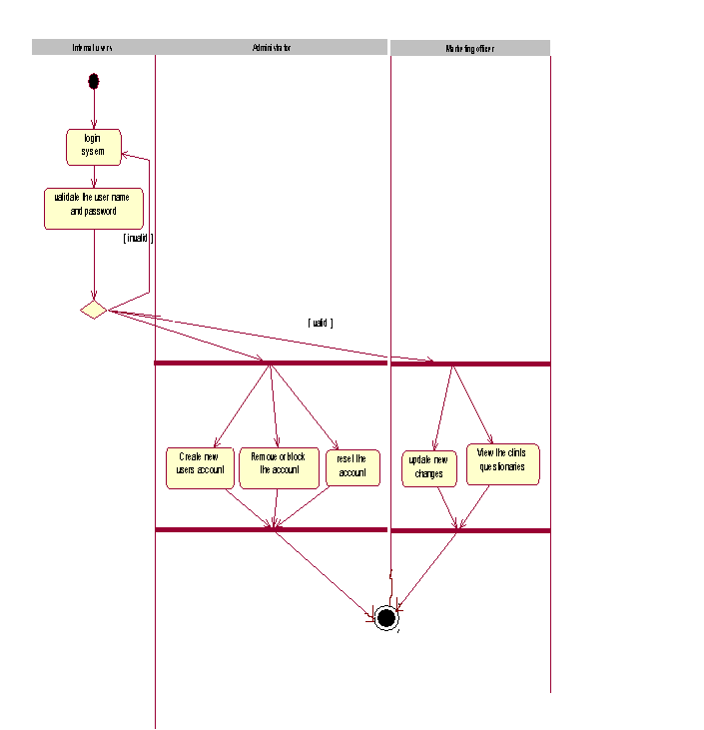

Design
We transform the specification into a form suitable for implementation in a programming language. Object oriented development methodology is used to build up the system as it is a more effective way of developing flexible software. Components needed for a successful project are notation, process and tool. The proposed system makes use of UML which stands for Unified Modeling Language as the notation, Unified process as the process and Rational Rose as the tool.
Any software development method is best supported by a tool. The tool used for this project is Rational Rose and the reasons for using Rational Rose are as follows.

Rose facilitates object-oriented analysis and design. It allows analysts, engineers, writers, and project managers to create, view, manipulate, and modify elements in a Unified Modeling Language (UML) across the entire enterprise, using one tool and one language. The tool’s true value is that it exposes software development problems early on in the development life cycle, helping you manage everything from straightforward projects to more complex software solutions. Basically, Rose supports use-case-driven object modeling.

First we identified the various objects that occur in the problem domain and the solution domain and the different kinds relationships that exist among these objects. This system is built so as to overcome the matters which were identified during the requirement gathering.

Below we are describing designed models as class diagram, sequence diagram, state machine diagram & deployment diagram for our system DMS.

Class Diagram

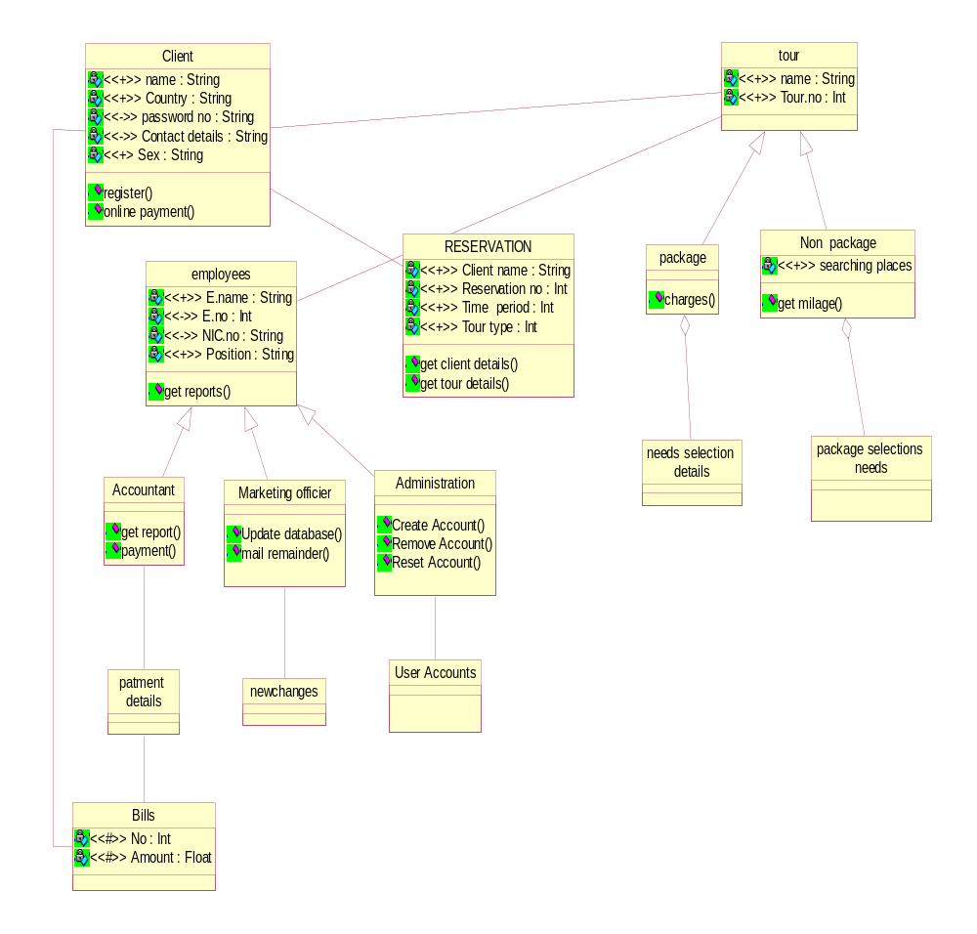

Sequence Diagram
2.2.2.1 Client reservation
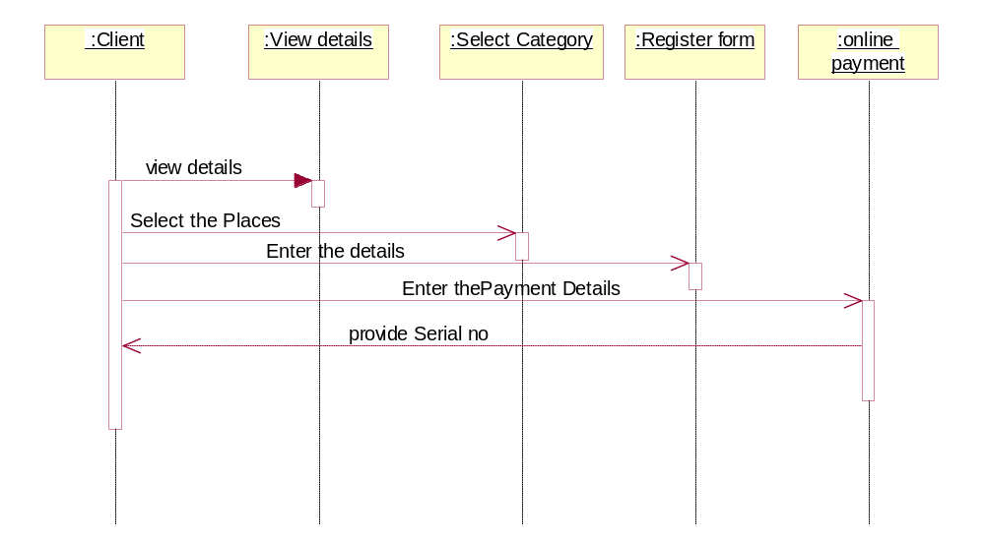

2.2.2.2 Cancel reservation
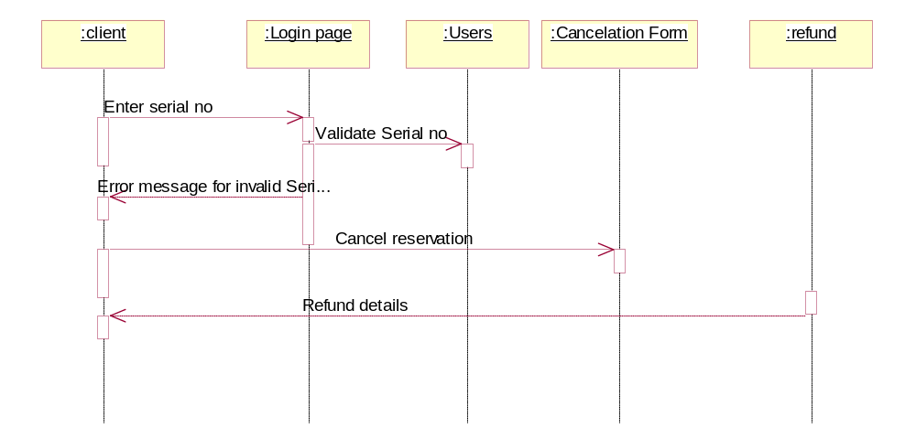

2.2.2.3 Update new charges

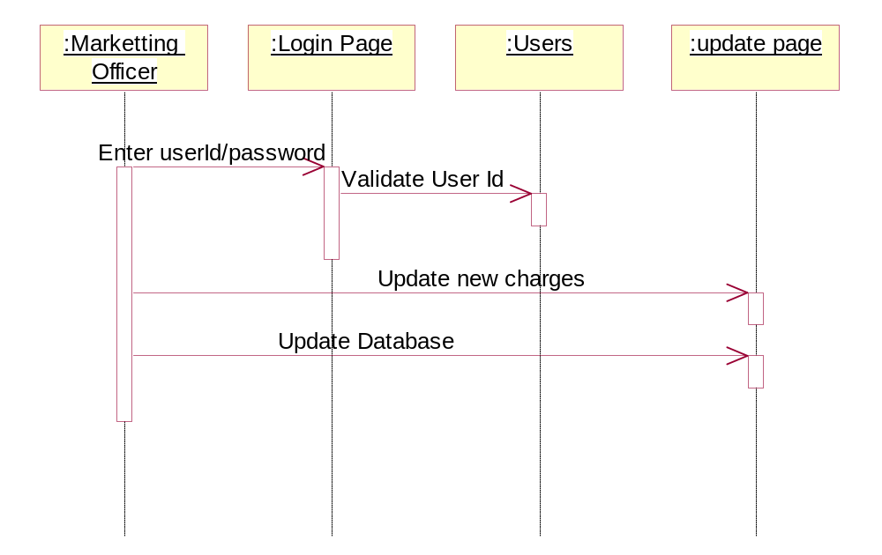

2.2.2.4 Mail Upcoming Events
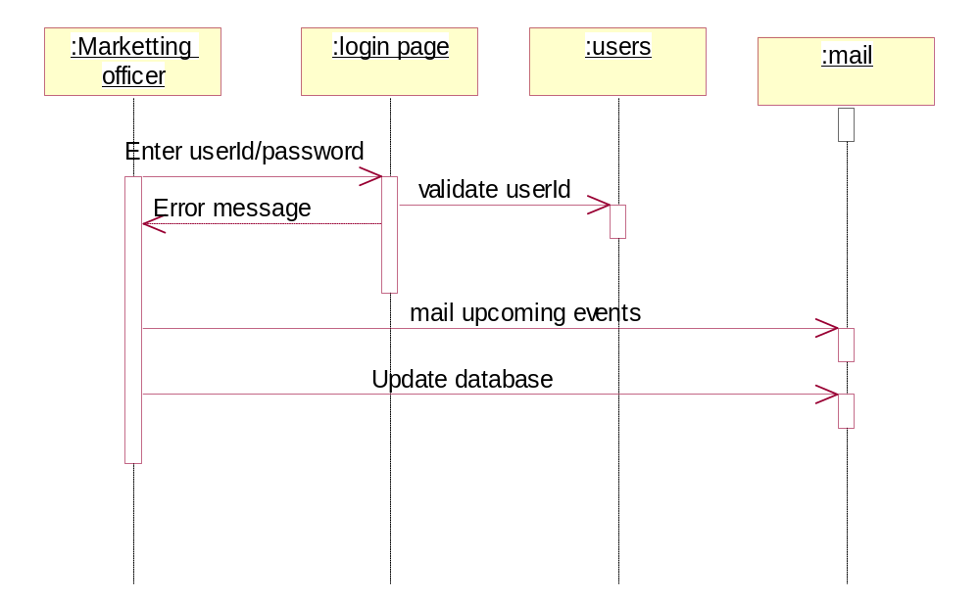

2.2.2.5 Create Reports
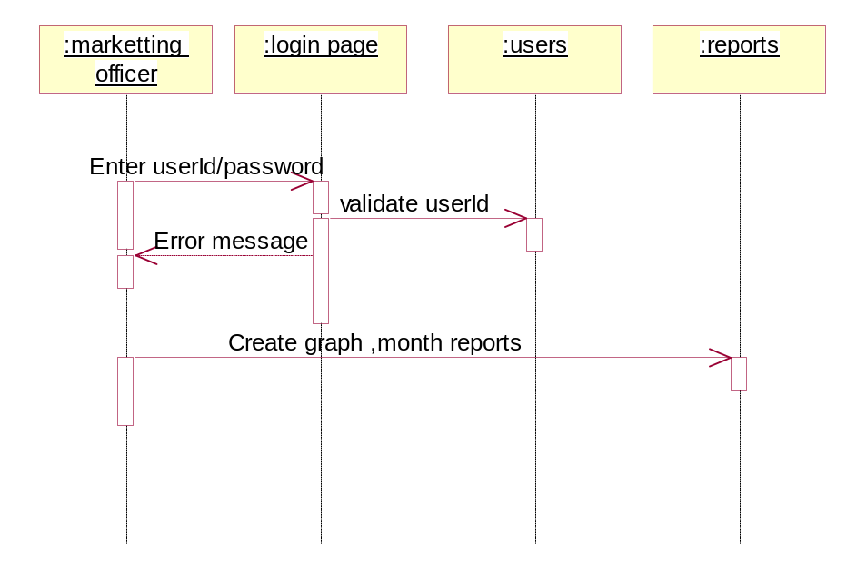

2.2.2.6 Administrator Functions

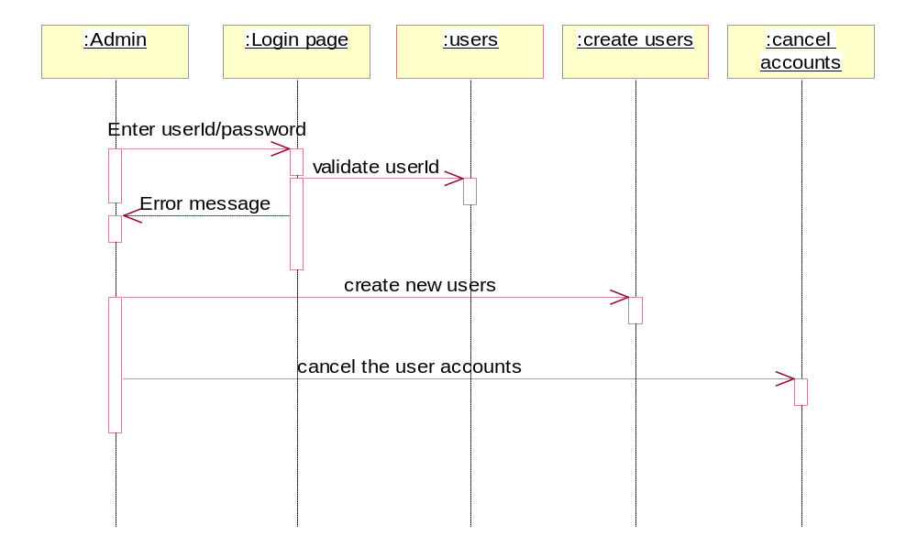

State machine Diagram

State machine diagram for tourist Rerservation

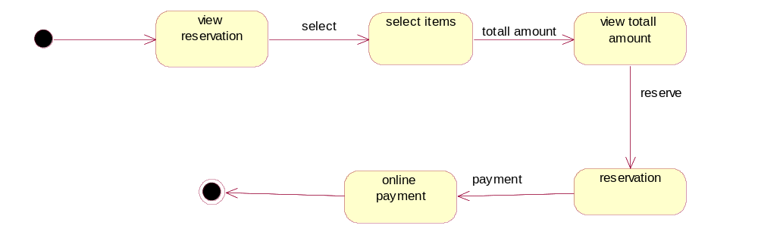

2.2.3.2 State machine diagram for marketing Officer

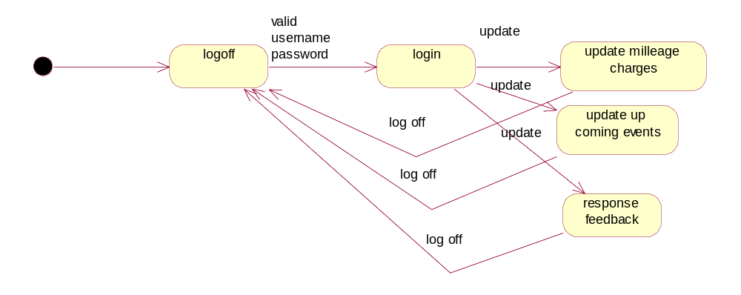

2.2.3.3 State machine diagram for administrator

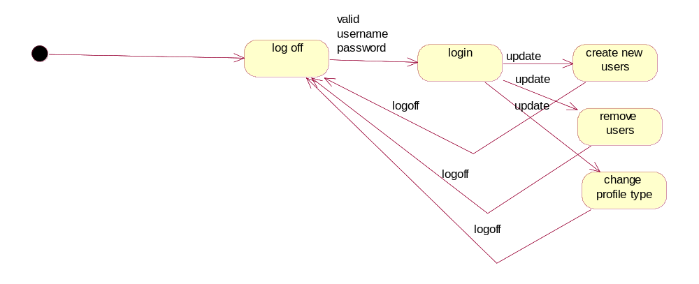

2.2.4 Combining of Deployment diagram and Component diagram

